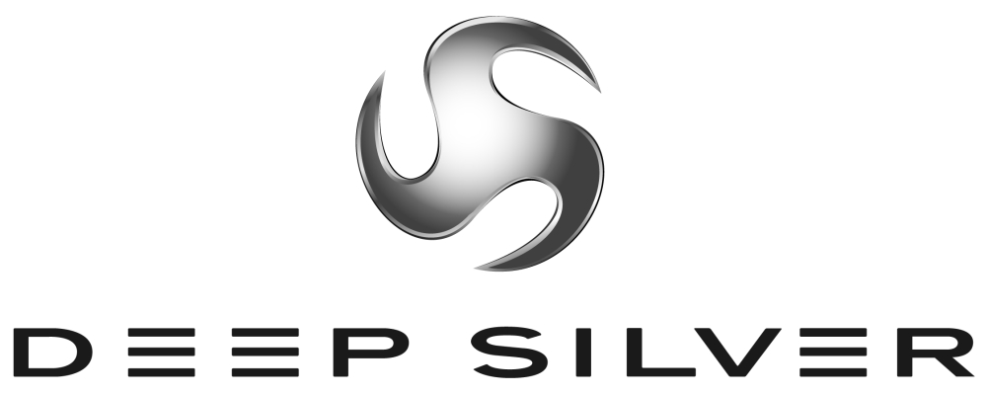
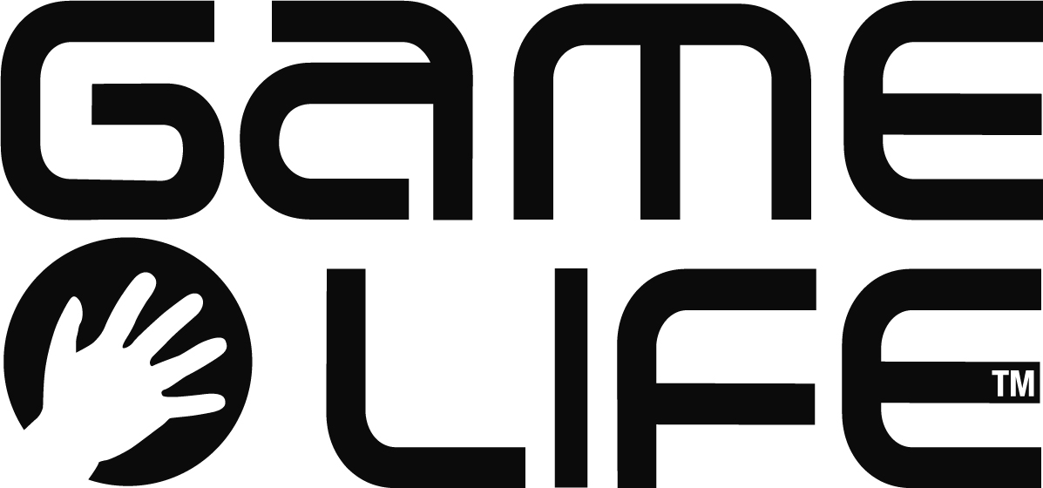
Press Information
Planegg/Germany, Paris/Frankreich, August 2008
International Press Contact:
Martin Metzler
Koch Media GmbH Tel: +49 89 24245-123
Lochhamerstr. 9 Fax: +49 89 24245-3 134
82152 Planegg/München m.metzler@kochmedia.com

Deep Silver and Game Life Announce
the Release of Baby Life

Life Simulation for Nintendo DS

Deep Silver, the games label of Koch Media, a leading producer and distributor of digital entertainment products, and French publisher Game life announce the release of the life simulation Baby Life for Nintendo DS™. Koch Media owns the publishing rights for all PAL regions.

In Baby Life, players take charge of their own, unique babies. A combination of different “genetic material” allows players to (pro)create a baby that almost no-one else could have, with more than 3 millions possibilities. Each baby is unique physically and mentally. The baby behaves very realistically, its movements are life-like, it plays, smiles or cries.
As parents you have to help your baby to grow up from 9 to 15 months, help her/him to speak, move, behave better and better.

More than 100 items of clothing can be used either for one’s own toddler or swapped with others via the integrated Nintendo Wi-Fi Connection. In the second part of the game players will have to demonstrate their newly acquired abilities when they babysit up to four children at once.

"Through Horse Life, Game Life have already demonstrated their excellence at creating life-like simulations. Baby Life allows a playful and at the same time motivating approach to a subject that we all know very well, and buyers will love it," says said Dr. Klemens Kundratitz, CEO of Koch Media, about the game Baby Life.

"We are confident that Baby Life will astonish the market by its quality and high playability, our target is to deliver real fun with the most lovely hero you can have in a videogame: a Baby," says Emmanuel Drouin, Managing Director of Game Life.

With the development of their successful Horse Life series, Game Life have gained valuable experience with life simulations.

Baby Life for Nintendo DS will be published in the fourth quarter of this year.

About Deep Silver
Deep Silver develops and distributes interactive games for all platforms. The Deep Silver label means to captivate all computer and video gamers who enjoy and share a passion for thrilling gameplay in modern game worlds. Deep Silver works with its partners to achieve a maximum of success while maintaining the highest possible quality, always focusing on what the customer desires. Deep Silver products are designed to equally appeal to professionals and beginners, children and adults.

Deep Silver has published around 40 games since 2003, including the most successful adventure of 2006, Secret Files: Tunguska, the bestseller ANNO 1701 (co-published with Sunflowers), the challenging CrossworDS knowledge puzzle game, the horse simulation Horse Life DS, and the soccer MMO World of Soccer Online. Current developments include Warhammer® - Battle March™ (in cooperation with Namco Bandai), the action role-playing game Sacred 2: Fallen Angel (in cooperation with Ascaron), S.T.A.L.K.E.R.: Clear Sky, the sinister Chernobyl shooter for PC, and the new game from the Piranha Bytes team. Deep Silver's own developing studio Deep Silver Vienna opened in 2007. For more information please visit www.deepsilver.com

Koch Media is a leading producer and distributor of digital entertainment products (software, games and movies on DVD). The company's own sales activities, marketing and distribution extend throughout Europe, and it has formed strategic alliances with numerous software and games manufacturers: Ascaron, Braingame, D3P, G-Data, Gamelife, Kaspersky Lab, Lexware, Namco Bandai, Pinnacle, Square Enix, Sony Online Entertainment, System3, etc. Headquartered in Planegg near Munich/Germany, Koch Media owns publishing and distribution branches in Germany, England, France, Austria, Switzerland, Italy, Spain and the USA. www.kochmedia.com

About GAME LIFE
Game Life is a dynamic independent videogame publisher, willing to release games with original concept, that are simply easy and fun to play. With its quality content and worldwide IP, Game Life teams are focusing their activities on next generation console games, working hard to offer the best gaming experience to the end users.

NINTENDO DS IS A TRADEMARK OF NINTENDO.

